MLA application deployment:

1. Open the mla application in eclipse and update the application.properties file with the database details and server details.
2. Create a run configuration in eclipse with below maven goals,

Clean package spring-boot:repackage

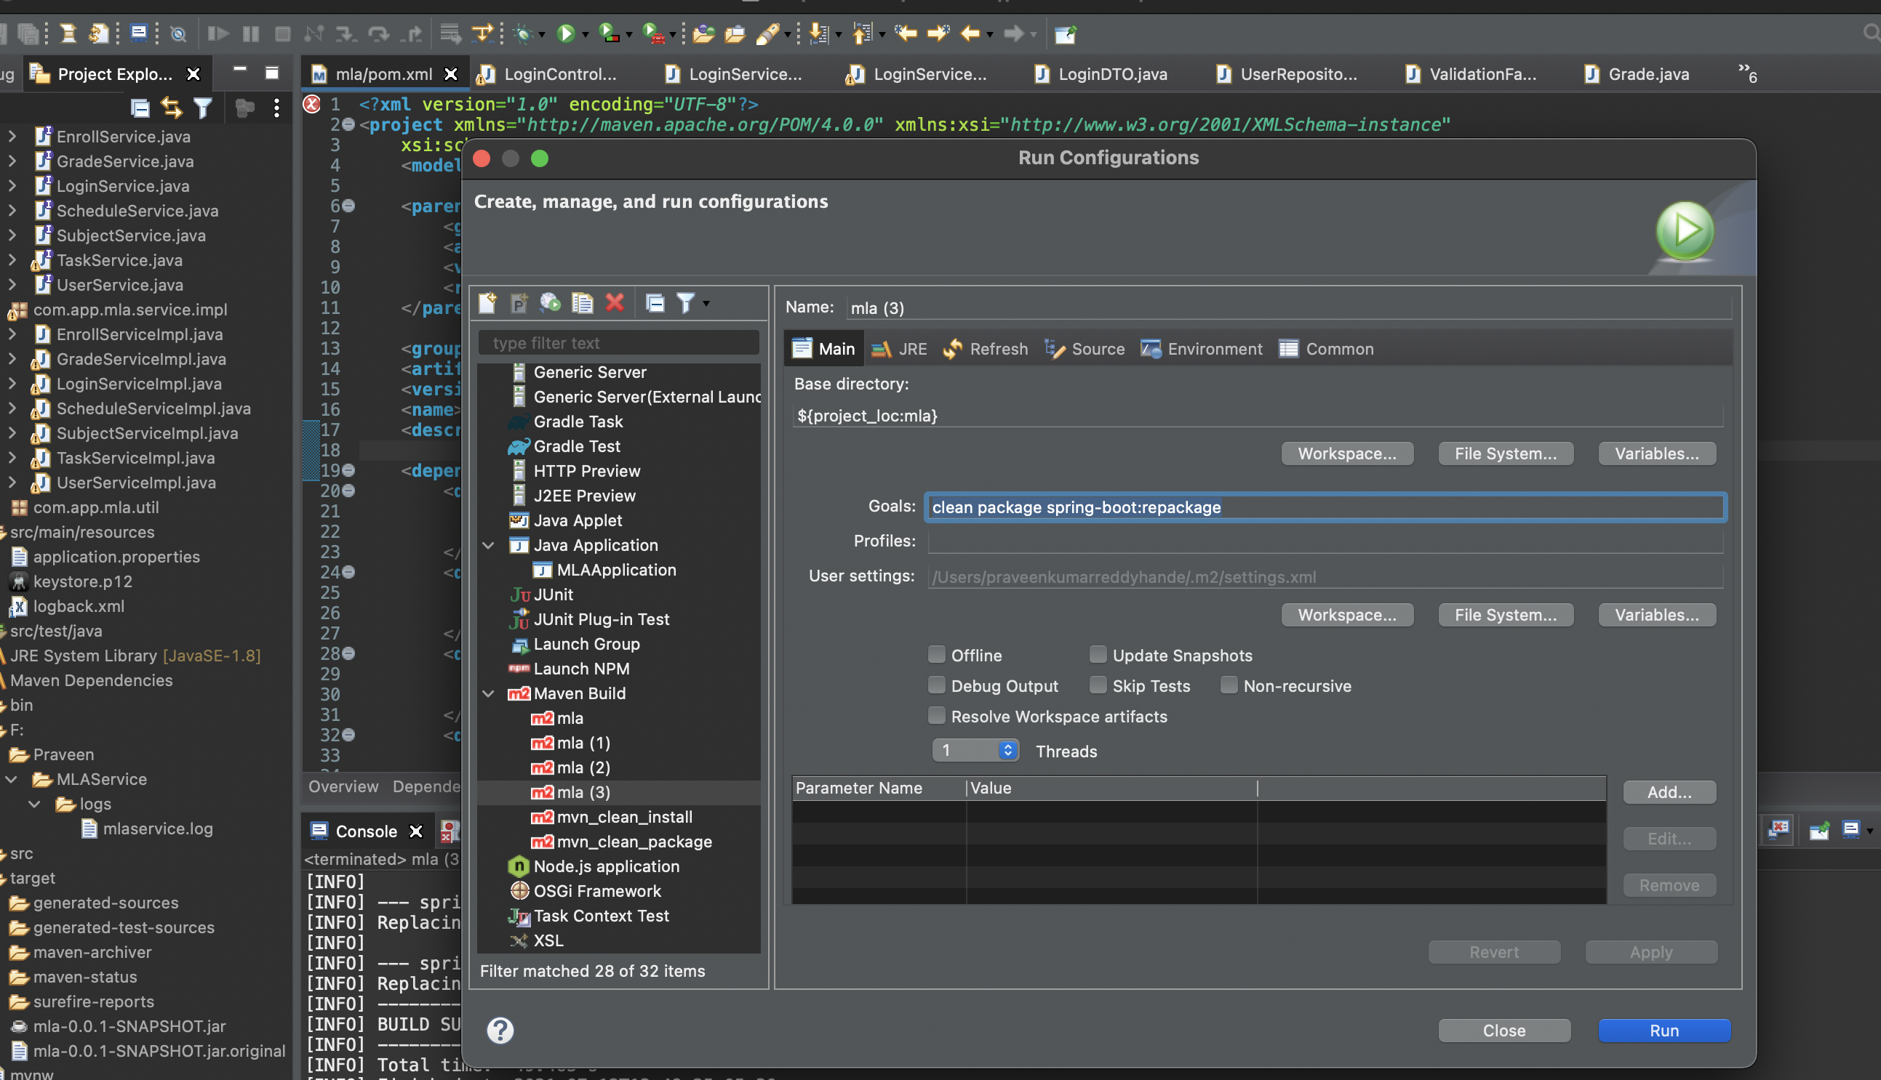

1. You will find a target folder created in the project root folder(mla)

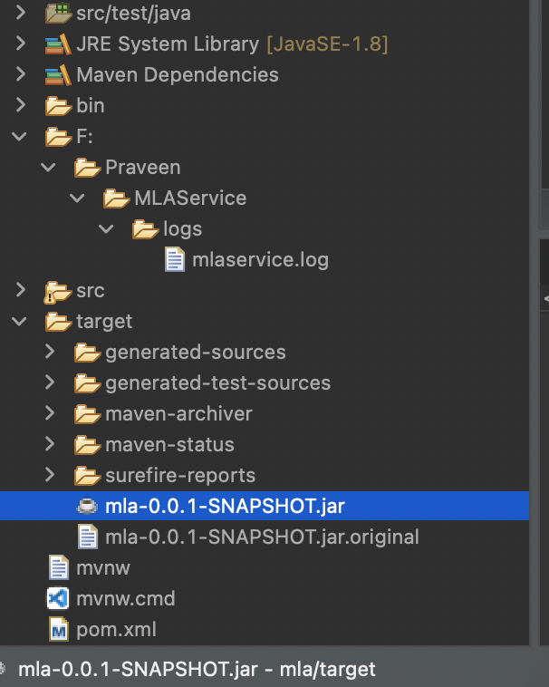

1. Once generated copy the above jar to the aws machine user home location using scp

Ex. scp -i sahithi_aws_keypair.pem mla/target/mla-0.0.1-SNAPSHOT.jar [ec2-user@ec2-3-133-104-14.us-east-2.compute.amazonaws.com:/home/ec2-user/](mailto:ec2-user@ec2-3-133-104-14.us-east-2.compute.amazonaws.com:/home/ec2-user/)

1. Once copy is done, execute the below command to see if the jar is deploying the web application as expected. (make sure java is installed on the aws machine)

Java -jar mla-0.0.1-SNAPSHOT.jar

You will see that the web application started successfully.

1. Now kill this process with Ctrl+C and start it as a shell detached process with below command

setsid nohup java -jar mla-0.0.1-SNAPSHOT.jar

This will output all the logs to nohup.log file in the same user folder location as the jar

The https related certs are bundles along with the jar through a custom cacert. The same will be used by the web application to enable users to connect through https.